Solar Month
# Source: AI Source: Provided by: [Data Path: Persons Table -> ID Column: 1, Name_En Column: Motasem Essam] -> From: [ChatGPT] on [7/17/2026]
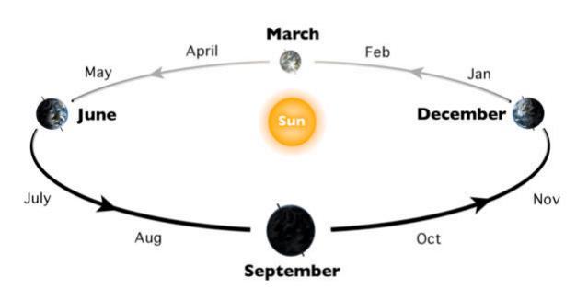
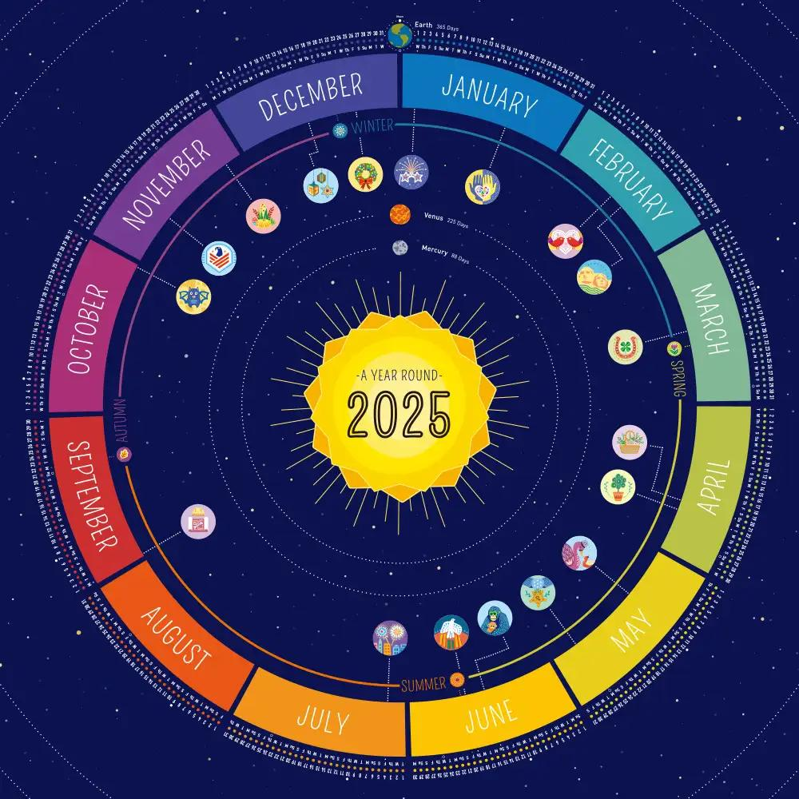
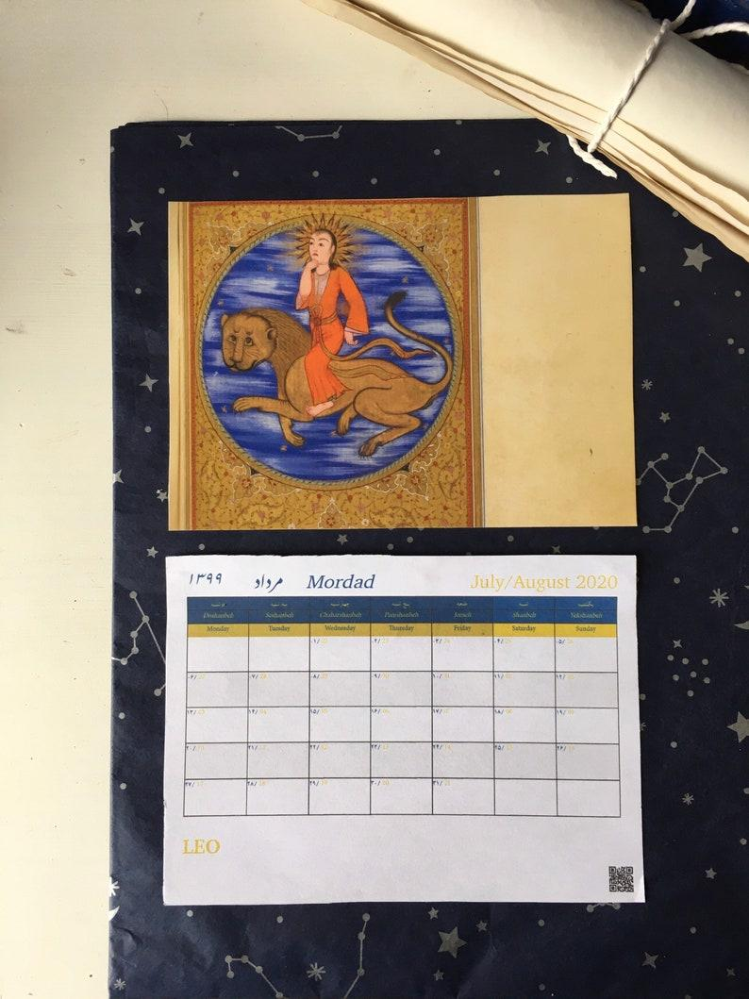
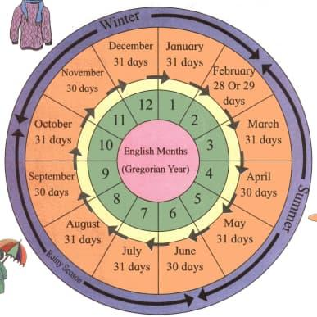
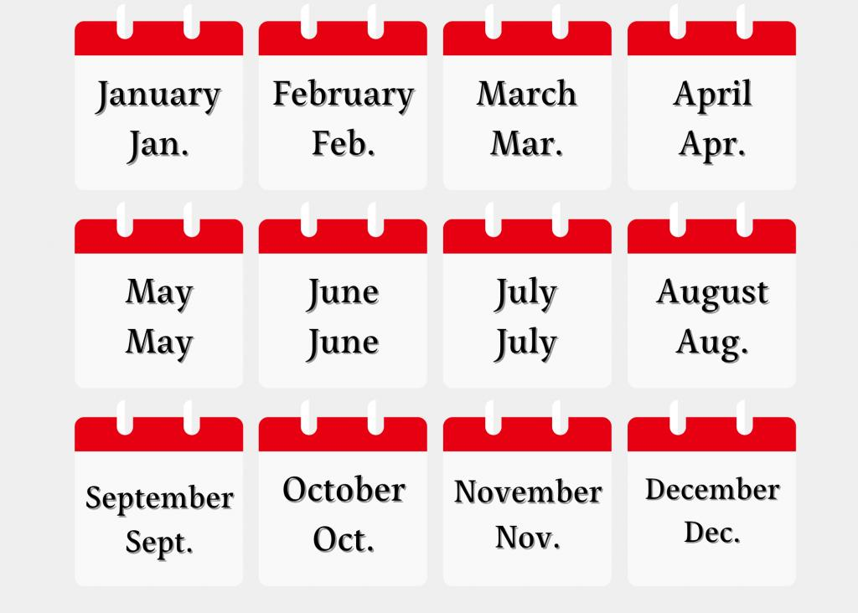
A Solar Month is a unit of time based on the Earth's position in its orbit around the Sun. Unlike a lunar month, which follows the Moon's phases, a solar month is derived from the solar year and is used in solar calendars to keep time synchronized with the seasons.
In modern solar calendars, such as the Gregorian Calendar and the Persian (Solar Hijri) Calendar, a solar month represents one of the fixed divisions of the solar year.

Definition
# Source: AI Source: Provided by: [Data Path: Persons Table -> ID Column: 1, Name_En Column: Motasem Essam] -> From: [ChatGPT] on [7/17/2026]
A Solar Month is a division of the solar year based on the Earth's revolution around the Sun, used in solar calendar systems to organize the year while maintaining seasonal alignment.

Astronomical Basis
# Source: AI Source: Provided by: [Data Path: Persons Table -> ID Column: 1, Name_En Column: Motasem Essam] -> From: [ChatGPT] on [7/17/2026]
A solar month is derived from the solar year, which is the time required for the Earth to complete one revolution around the Sun.
Average length of a tropical (solar) year:
$$365.2422\text{ days}$$
Since a year contains 12 months, the average length of a solar month is:
$$\frac{365.2422}{12}≈30.44\text{ days}$$

Length of a Solar Month
# Source: AI Source: Provided by: [Data Path: Persons Table -> ID Column: 1, Name_En Column: Motasem Essam] -> From: [ChatGPT] on [7/17/2026]
The average solar month is:
$$30.44\text{ days}$$
However, actual month lengths depend on the calendar system.
Gregorian Calendar
- 28 days (29 in leap years)
- 30 days
- 31 days
Persian (Solar Hijri) Calendar
- First 6 months: 31 days
- Next 5 months: 30 days
- Final month: 29 days (30 in leap years)

Relationship to the Solar Year
# Source: AI Source: Provided by: [Data Path: Persons Table -> ID Column: 1, Name_En Column: Motasem Essam] -> From: [ChatGPT] on [7/17/2026]
A solar year consists of:
- 12 solar months
Together they form:
- 365 days in a common year
- 366 days in a leap year

Use in Calendar Systems
# Source: AI Source: Provided by: [Data Path: Persons Table -> ID Column: 1, Name_En Column: Motasem Essam] -> From: [ChatGPT] on [7/17/2026]
Solar months are used in:
Gregorian Calendar
- Most widely used civil calendar in the world.
- Months have fixed lengths.
Persian (Solar Hijri) Calendar
- Official calendar of Iran and Afghanistan.
- Months are arranged to maintain close alignment with the seasons.

Seasonal Alignment
# Source: AI Source: Provided by: [Data Path: Persons Table -> ID Column: 1, Name_En Column: Motasem Essam] -> From: [ChatGPT] on [7/17/2026]
One of the main advantages of solar months is that they remain aligned with the seasons.
For example:
- Spring always begins around March in the Northern Hemisphere.
- Summer always follows spring.
- Autumn and winter occur in predictable seasonal order.
This makes solar months especially useful for:
- Agriculture
- Education
- Government
- Business
- Scientific observations

Applications
# Source: AI Source: Provided by: [Data Path: Persons Table -> ID Column: 1, Name_En Column: Motasem Essam] -> From: [ChatGPT] on [7/17/2026]
Solar months are used in:
- Civil calendars
- Government administration
- Education
- Banking
- Business reporting
- Scientific records
- Agriculture
- Historical chronology

Advantages
# Source: AI Source: Provided by: [Data Path: Persons Table -> ID Column: 1, Name_En Column: Motasem Essam] -> From: [ChatGPT] on [7/17/2026]
Solar months:
- Stay synchronized with the seasons.
- Provide predictable scheduling.
- Simplify long-term planning.
- Support international standards.
- Are suitable for agriculture and climate-based activities.

Limitations
# Source: AI Source: Provided by: [Data Path: Persons Table -> ID Column: 1, Name_En Column: Motasem Essam] -> From: [ChatGPT] on [7/17/2026]
Solar months:
- Do not correspond exactly to the Moon's phases.
- Have unequal lengths in many calendars.
- Require leap-year adjustments to maintain long-term accuracy.

Comparison with Other Types of Months
# Source: AI Source: Provided by: [Data Path: Persons Table -> ID Column: 1, Name_En Column: Motasem Essam] -> From: [ChatGPT] on [7/17/2026]
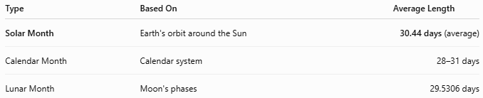
Type | Based On | Average Length
Solar Month | Earth's orbit around the Sun | 30.44 days (average)
Calendar Month | Calendar system | 28–31 days
Lunar Month | Moon's phases | 29.5306 days

Common Mistakes
# Source: AI Source: Provided by: [Data Path: Persons Table -> ID Column: 1, Name_En Column: Motasem Essam] -> From: [ChatGPT] on [7/17/2026]
- Confusing a solar month with a calendar month. A calendar month is a practical division of a calendar, while a solar month is conceptually based on the Earth's movement around the Sun.
- Assuming every solar month has exactly 30 days.
- Believing solar months follow the Moon's phases.

Interesting Facts
# Source: AI Source: Provided by: [Data Path: Persons Table -> ID Column: 1, Name_En Column: Motasem Essam] -> From: [ChatGPT] on [7/17/2026]
- A solar month is approximately 30.44 days long on average.
- Solar calendars are designed to keep months aligned with the Earth's seasons.
- The Gregorian Calendar and the Persian (Solar Hijri) Calendar are examples of solar calendar systems.

Key Points
# Source: AI Source: Provided by: [Data Path: Persons Table -> ID Column: 1, Name_En Column: Motasem Essam] -> From: [ChatGPT] on [7/17/2026]
Key Points
- A Solar Month is based on the Earth's revolution around the Sun.
- Twelve solar months make one solar year.
- The average length of a solar month is:
$$30.44\text{ days}$$
- Solar months remain synchronized with the seasons.
- They are used in solar calendars such as the Gregorian Calendar and the Persian (Solar Hijri) Calendar.

Conclusion
# Source: AI Source: Provided by: [Data Path: Persons Table -> ID Column: 1, Name_En Column: Motasem Essam] -> From: [ChatGPT] on [7/17/2026]
A Solar Month is one of the twelve divisions of a solar year, derived from the Earth's orbit around the Sun. Averaging about 30.44 days, it forms the basis of solar calendar systems that remain aligned with the seasons. Although the exact number of days varies between months in different calendars, solar months provide a stable and practical framework for civil administration, education, agriculture, science, and everyday life by preserving the regular progression of the seasons.

